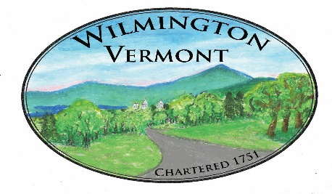
TOWN OF WILMINGTON
OFFICE OF THE TOWN CLERK

Overview

Property Transfer Tax is a tax on the transfer of title to real property in Vermont. The tax applies to both property transfers by deed and to acquisitions of a controlling interest in an entity with title to a property.

How to File and Pay
Please note when recording a deed: Complete Form PTT-172, Vermont Property Transfer Tax Return with identification numbers and one additional copy with the ID number redacted. Deliver the deed(s) and return to the town clerk. The clerk will record the deed(s) and they will send the copy(ies) with the identification numbers to the Department.
Payments
If tax is due at the time of transfer by deed, please make checks payable to the Vermont Department of Taxes and complete Form PTT-173, Property Transfer Payment Voucher and send to:
Vermont Department of Taxes
133 State Street
Montpelier, VT 05633-1401

Here is a link to the Vermont Department of Taxes giving all the forms needed for filing in fillable form https://tax.vermont.gov/property/ptt along with some additional information that you may find helpful.

As always please feel free to contact us should you have any questions.

