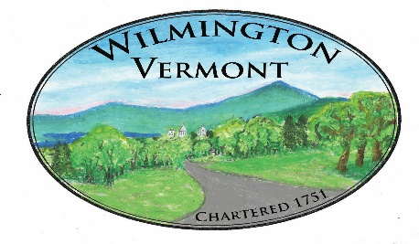
TOWN OF WILMINGTON
OFFICE OF THE TOWN CLERK
HOW TO TRANSFER A MOBILE HOME BETWEEN PARTIES
Selling or Buying a Mobile Home?
Here is a link to very helpful information: https://tax.vermont.gov/sites/tax/files/documents/FS-1275.pdf
Below are Recording Requirements:
If you are selling or buying a mobile home and it is staying on the same property you must:
- Documents: Fill out and have seller(s) and buyer(s) sign a Vermont Mobile Home Bill of Sale https://tax.vermont.gov/sites/tax/files/documents/PVR-2602C.pdf

- Complete a Vermont Property Transfer Tax Return and have seller(s) and buyer(s) sign it. https://tax.vermont.gov/sites/tax/files/documents/PTT-172-2020.pdf

3) Transfer Tax: Contact the Vermont Department of Taxes to find out how to compute and pay any State transfer tax due.
- Recording Fee: $15 per page for the Mobile Home Bill of Sale and a flat fee of $15 for the VT Property Transfer Tax Return regardless of the number of pages. For example: a 2-page Mobile Home Bill of Sale with a VT Property Transfer Tax Return = $45 recording fee, payable to Town of Wilmington.
- Local Property Taxes: Contact the Wilmington Tax Office at 802-464-8591 Ext 112 or crichter@wilmingtonvt.us to verify that taxes for the year are current and obtain a paid tax receipt. Any delinquent taxes will become the buyer’s responsibility.

- What the Town Clerk needs for recording: Forward the following (1) Mobile Home Bill of Sale, (2) VT Property Transfer Tax Return, (3) Recording Fee, (4) Paid Tax Receipt and (5) Postage Paid Return Envelope to Town Clerk, P.O. Box 217, Wilmington, VT 05363.

The seller is responsible for the Transfer Tax and Filing Fee. The Town Clerk will record the transfer of ownership and return original documents, so be sure to include a self-addressed envelope. The buyer of the mobile home will now appear as the owner of record and will receive the tax bill from the Town.

