The Power of Dignity
A Community Conversation on Substance Use
Deerfield Valley: Opioid-related deaths in Vermont continue to rise, and harmful substance use has touched almost everyone in the community. Even though no individual or organization has all the answers, community conversations grounded in mutual respect help generate dignified solutions to challenges related to substance use.
Please join Community Substance Use Response (CSUR) and Voices of Hope in a public conversation about substance use at the Municipal Center in Jacksonville, VT, 2948 VT Route 100 S (next to the Whitingham Library) from 5:30 to 7:00 p.m. on Thursday August 3, 2023.

Come explore and discuss:
• What is substance use, addiction, abstinence;
• How can we support treatment and help prevent harmful substance use;
• Why we meet people where they are and promote harm reduction;
• The importance of compassion and accountability.

Communities have far more power to influence harmful substance use than many community members realize. Community members enhance that power when they gather and share stories and insights.

Conversations about harmful substance use often involve pain, loss, and negative judgments. We recognize this yet anticipate a conversation where everyone gives and receives dignity, where everyone is listened to, and where participants share without judgment, scapegoating, or blame.

Community Substance Use Response (CSUR) represents several organizations including: Voices of Hope in Deerfield Valley; Turning Point of Windham County; The AIDS Project of Southern Vermont in Brattleboro; Grace Cottage Hospital; Building a Positive Community (BAPC); and Meetinghouse Solutions.

Funding for CSUR is provided by the Vermont Department of Health Division of Substance Use.
For more information, contact Voices Of Hope voicesofhopevt@gmail.com.
Robin Rieske, Voices of Hope Coordinator
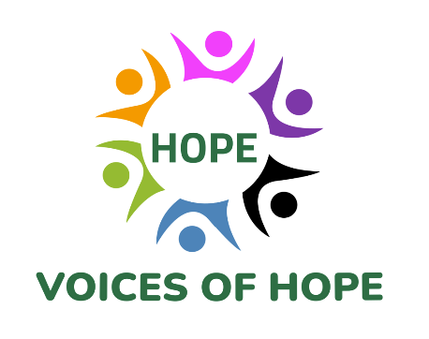
www.voicesofhopevt@gmail.com
facebook.com/VoicesofHopeVT
(802) 490-3316 Voices
(802) 490-5645 Recovery Support Services

