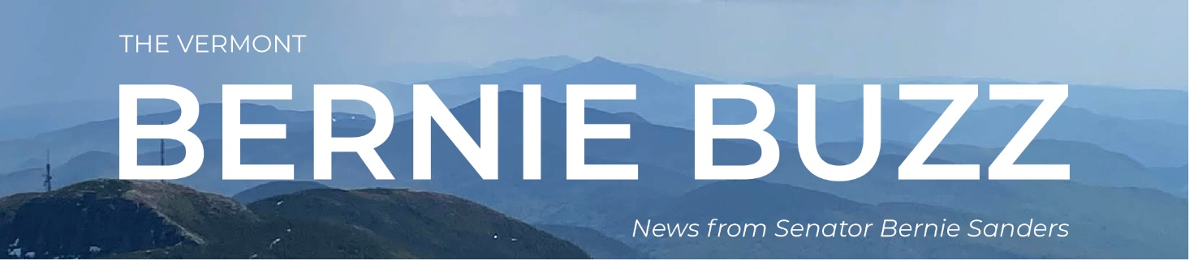

PLEASE READ: Emergency Flooding Resources
Dear Fellow Vermonter,
Nobody knows for sure, but the flooding we are now experiencing could be the worst Vermont has seen in a very long time.
What we do know is that extensive damage is already occurring in the towns of Weston, Ludlow, Londonderry, Calais, and many more.
We also know that a number of roads have been closed, including sections of Route 100, 14, 131, 12, 12A, 14, 2, 103, 140, 107, and 155. Vermonters can stay up-to-date on road closures by visiting the Vermont Agency of Transportation website or New England 5-1-1.
In terms of roads, please remember: Flash flooding is extremely dangerous and could result in loss of life. If you have to travel in flooded areas, be extremely careful. Vermonters should monitor media reports, follow instructions from Vermont Emergency Management, never attempt to walk or drive through flood waters, and familiarize yourself with your best flood evacuation routes.
This morning, I spoke with FEMA Administrator Deanne Criswell about the disaster declaration requested by Governor Scott that Senator Welch, Representative Balint, and I fully support. I hope the White House will approve this request later today. This declaration will enable various types of federal support to come into the state as soon as possible. In speaking with the FEMA Administrator, I also requested that she send FEMA staff into flooded areas as soon as it is safe so that residents can learn about the type of help that may be available to them.
A special thanks to the road crews and all emergency workers who are working around the clock to protect lives and property. They are doing a great job under extremely difficult circumstances. I also want to thank the crews who are on their way from around our region and as far away as North Carolina. I also appreciate the Vermont National Guard as well as National Guards from our neighboring states who stand at the ready to assist us if needed.
Please see below for additional resources and stay tuned for more updates. As always, if you know someone who would benefit from this information, please forward this email to them.
We will get through this together.
Sincerely,
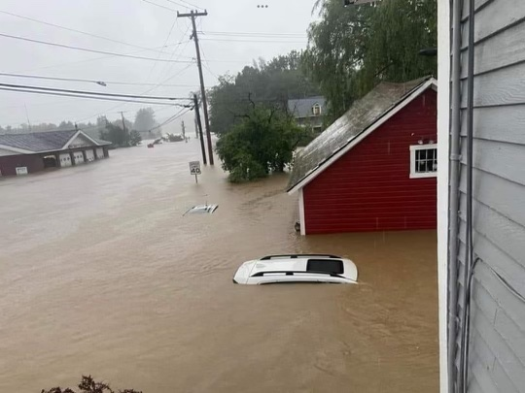
Weston, VT. Source: Community Member

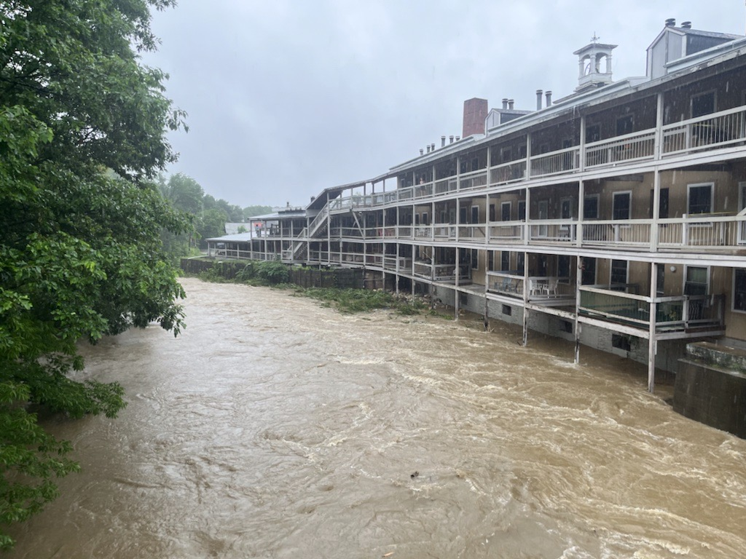
Depot Street in Ludlow, VT. Source: Community Member

Stay Informed, Get Emergency Alerts
It is imperative that Vermonters stay safe as the flash flood risk continues through today and as long as a flood watch remains in effect. Vermonters should monitor media reports, follow instructions from Vermont Emergency Management, never attempt to walk or drive through flood waters, and familiarize yourself with your best flood evacuation routes. See below for some key resources.
- 2-1-1: For help getting connected to resources and services such as shelter, disaster response, and more, call 2-1-1.
- 9-1-1: For emergency situations, always call 9-1-1.
- Language Translations for Flood Resources: https://www.healthvermont.gov/emergency/prepare/stay-safe-flood
- Vermont Emergency Management:
  - Twitter: @vemvt
  - Facebook: https://www.facebook.com/vermontemergencymanagement
- VT-Alert: VT-ALERT is used by the state and local responders to notify the public of emergency situations. Those include, but are not limited to, evacuation information, chemical spills, shelter-in-place alerts, severe weather advisories, boil water advisories, and roadway interruptions. NOTE: Residents can tailor the alerts to specific locations, types of alerts, and on which devices they will be notified.
  - Sign up to receive VT-Alerts, here: https://vem.vermont.gov/vtalert
  - Follow VT-Alert on social media for quick updates:
    - Twitter: https://twitter.com/vermontalert
    - Facebook: https://www.facebook.com/VermontAlert

Some Flood Safety Best Practices
- Never drive or walk through floodwaters. Strong currents or unseen washouts can sweep you and your car away.
- Turn off the circuit breaker in your home before you evacuate – if you can do so safely.
- If rising water is approaching, leave.
- If you need to evacuate, do so over high ground. Plan that route as soon as possible.
- If your home floods, have a licensed electrician inspect your electrical system before you once again occupy your home.
- If you are in a flood-prone area, or if you believe your home will be flooded, it is advisable to move valuables from your basement in case water enters your home.
- Check your insurance coverage now, and then contact your insurance company if you have damage.

Additional Resources for Emergency Updates
For additional updates, you can find below some recommended social media accounts to follow:
- VT State Police:
  - Facebook: https://www.facebook.com/VermontStatePolice/
  - Twitter: https://twitter.com/VTStatePolice
- VT Division of Fire Safety:
  - Facebook: https://www.facebook.com/VTFireMarshal
  - Twitter: https://twitter.com/VTFireMarshal
- VT Agency of Transportation:
  - Facebook: https://www.facebook.com/VTransontheroad/
  - Twitter: https://twitter.com/AOTVermont
- VT Department of Health:
  - Facebook: https://www.facebook.com/HealthVermont/
  - Twitter: https://twitter.com/healthvermont
- National Weather Service Burlington:
  - Facebook: https://www.facebook.com/NWSBurlington/
  - Twitter: https://twitter.com/NWSBurlington
- National Weather Service Albany:
  - Facebook: https://www.facebook.com/NWSAlbany/
  - Twitter: https://twitter.com/NWSAlbany

How Can We Help?
My Vermont offices have experienced caseworkers on staff who help Vermonters navigate federal agencies every day. If you think my office can help, please do not hesitate to call 1-800-339-9834 or click here.
If you would like to share your thoughts on pending legislation, or if you have an idea that we could address through new legislation, click here.
Receiving this email as a forward? Click here to sign up for the Bernie Buzz.
Office Locations

Washington D.C.  U.S. Senate  332 Dirksen Building  Washington, DC 20510  tel (202) 224-5141  fax (202) 228-0776 | Burlington  1 Church St., Suite 300  Burlington, VT 05401  tel (802) 862-0697  tel (800) 339-9834  fax (802) 860-6370

Unsubscribe
Click here to forward this email

