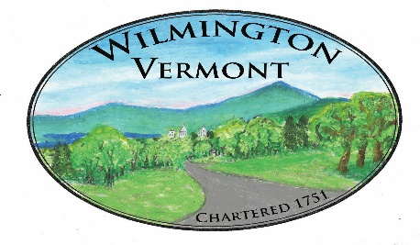
TOWN OF WILMINGTON
OFFICE OF THE TOWN CLERK

Summary of Vermont Recording Fees

Document recording fees*: $15.00 Per Page

PTTR recording fees: $15.00 Per Document**
(Property Transfer Tax Return)

Survey plat recording fees: $25.00 Per Sheet

Certified copy of records: $10.00 per page

Examination of records: $4.00 per hour
(Vault Time – at Clerk’s discretion)

*Documents include all items recorded in the land records.
(Deeds, mortgages, assignments, liens, releases, permits)

*Multiple assignments or releases included on one document are charged $15.00 per assignment or release.

See Clerk with any questions

