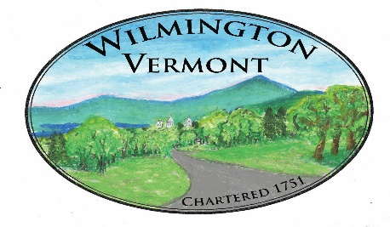
TOWN OF WILMINGTON
OFFICE OF THE TOWN CLERK

How to add, delete or change a name on a mobile home title?

To add, delete or change a name to on the title of a manufactured/mobile home, the owner must: Present the title (properly assigned), any required supporting documents and Property Tax Transfer form to the Motor Vehicle Department.

There is a fee required to transfer the title. Check with your local Department of Motor Vehicles.

